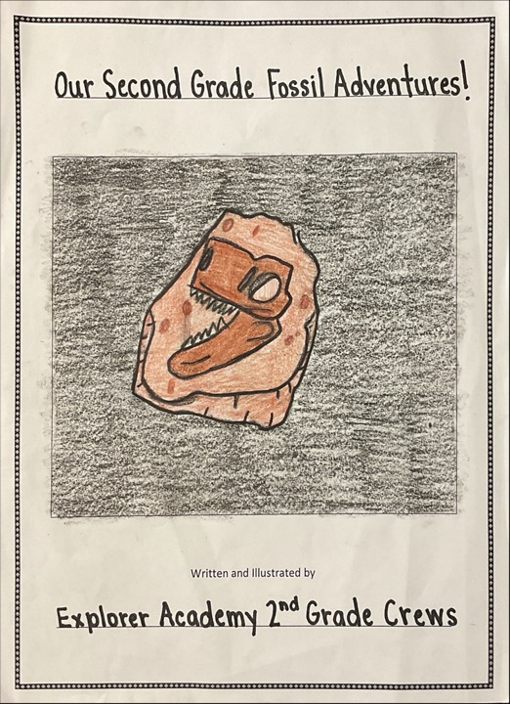

The second graders at Explorer Academy have been learning about fossils and what they can teach us about what life was like long ago, and what slow changes have happened. We’ve learned that fossils can help us understand what plants and animals lived long ago and how the earth has changed. We’ve also studied that Paleontologists are people who look for, unearth, and study fossils.

Our Second Grade Fossil Adventures!

Written and illustrated by
Explorer Academy Second Grade Crews
2021-2022

I am Persieus. I am at the hot desert, and I have a hammer and a brush.
I was digging and I saw something it was a fossil. It was big and it had a long neck.
I was happy because I found a fossil. I wonder how old it is.
I am taking the fossil to my lab. I will study it.

Written By: Persieus A.
Crew: Screech Owls

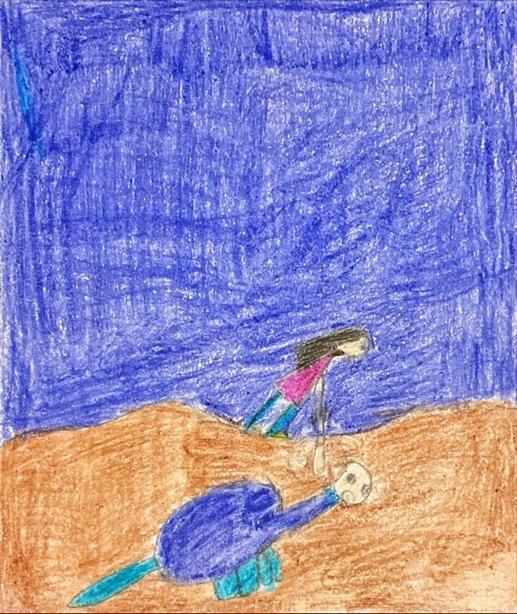

My name is Deante. I am in the desert looking for fossils. I have a hammer and a brush.
Suddenly I saw something. I used my hammer to break the rock. Then I brushed away the dirt. It was a fossil. It was big and sharp.
I felt tired after finding the fossil. I wondered how old the fossil was.
After finding the fossil I am sending it to a museum.

Written By: Deante A.
Crew: Screech Owls
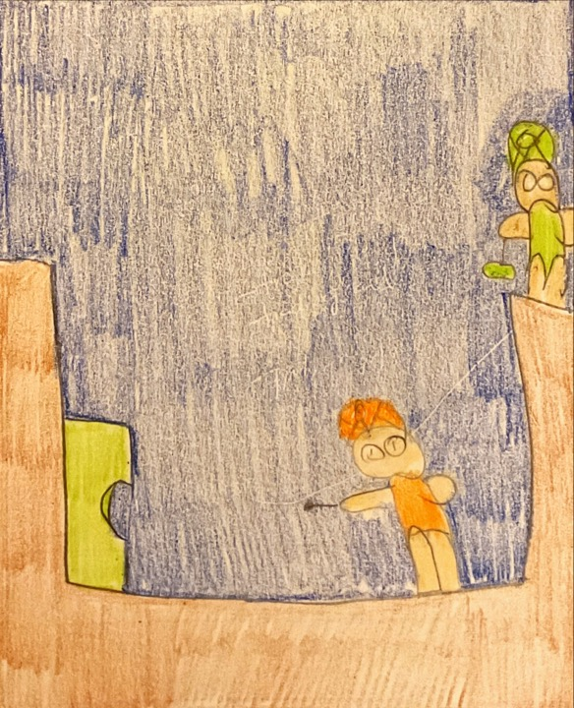

I am Donte. I am in the Savannah. I am looking for a t-rex fossil! I have a chisel and a brush.
I was digging and suddenly found something. I was big and had sharp teeth.
I was happy and excited to find a fossil. I wonder how old the fossil is.
After finding the fossil I am taking it to my lab. At my lab I am going to study the fossil.

Written By: Donte A.
Crew: Screech Owls
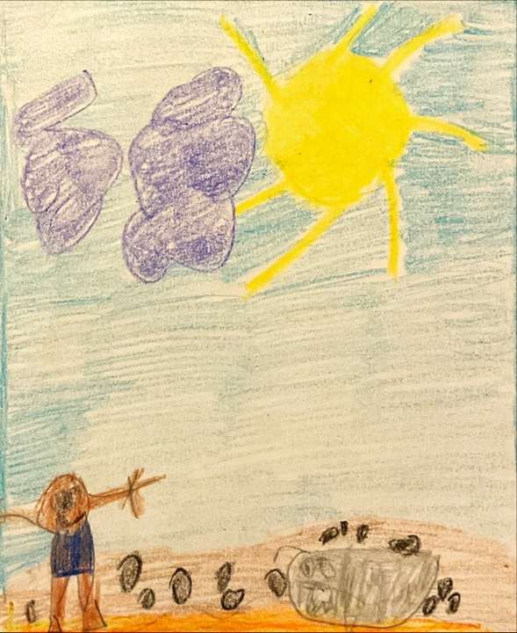

My name is Deandre. I am in a desert. I have an axe and hammer.
I was digging in the dirt. Suddenly I saw something big.it was a fossil.
I was happy to find a fossil. I wondered it was.it was so big.
I will take the fossil to a museum.

Written By: Deandre B.
Crew: Screech Owls
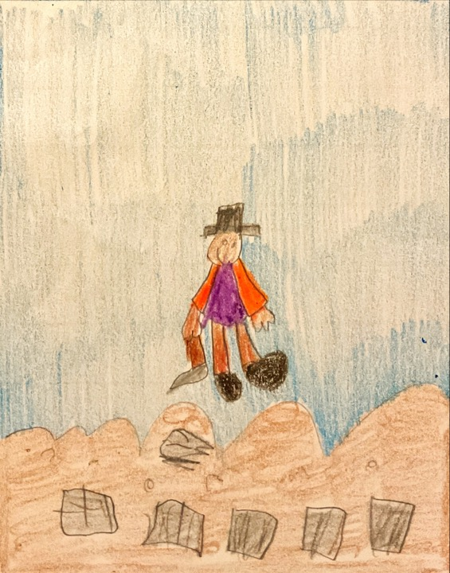

My name is Brielle. I was at a hot desert. I was using a pickaxe and a chisel.
The bone was so big it had a long neck. I was shocked that I found the bone I was trying to find.
I felt so happy that I found the bone. I thought I would not find the bone; it was so cool. I really wonder how old it was.
I am going to bring the fossil to the lab and examine it.

Written By: Brielle B.
Crew: Screech Owls
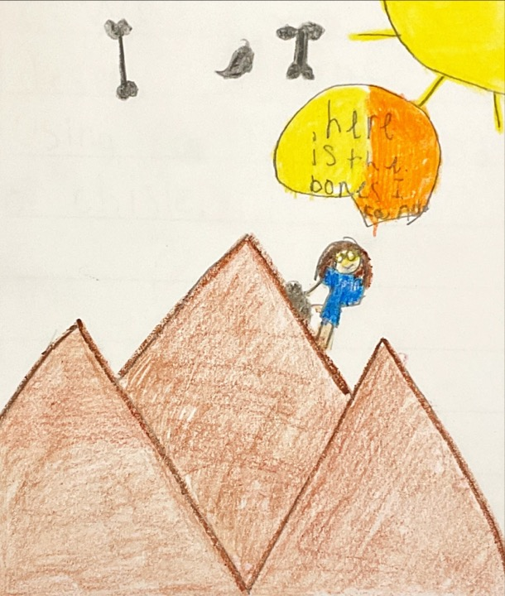

My name is paisley. I was at the beach looking for fossils. I had a brush and shovel.
I was digging for a fossil when suddenly I saw something.it was big. I finally got it out.
I was happy I found a fossil. I wonder what the fossil is.
I am taking the fossil to a lab to be studied.

Written By: Paisley C.
Crew: Screech Owls
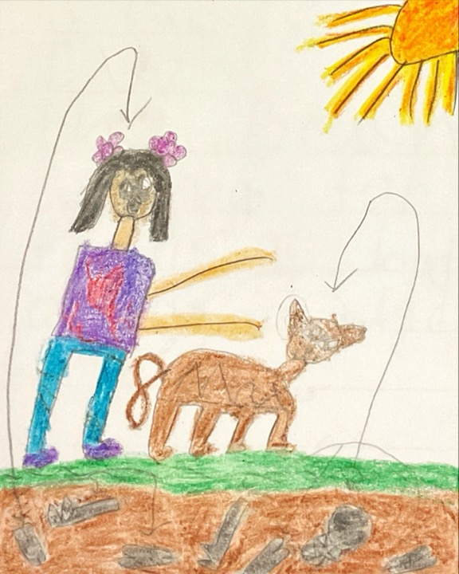

My name is Mark. I am at the beach. I am looking for a fossil. I have a jackhammer, brush, and a shovel.
I was using my shovel when I saw something.it was big and had teeth. I found a t-rex bone.
I was happy to find the fossil. I was also tired from digging. I wonder how it got there.
I am taking this fossil to a museum.

Written By: Mark H.
Crew: Screech Owls
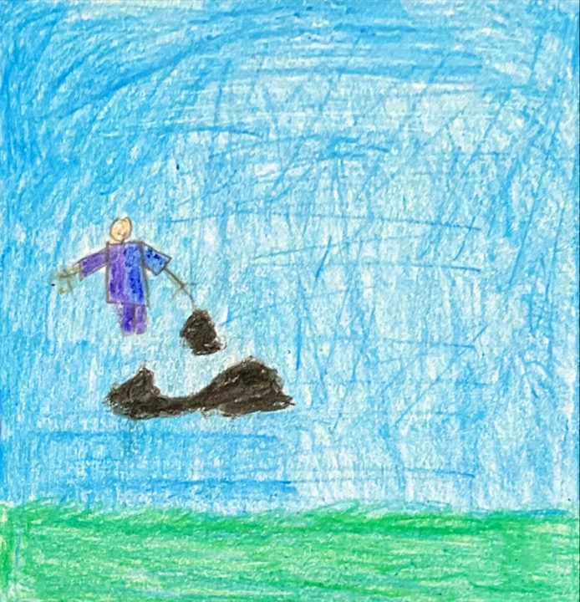

I was in the hot Savannah. I was trying to find a fossil. I had a pickaxe, chisel, brush, a hammer.
I was digging in the Savannah. I saw something. The fossil was big.it was also long.
I feel happy to find the fossil. I am also tired from digging. I wonder how old the fossil is.
I am going to sell the fossil.

Written By: Josiah H.
Crew: Screech Owls
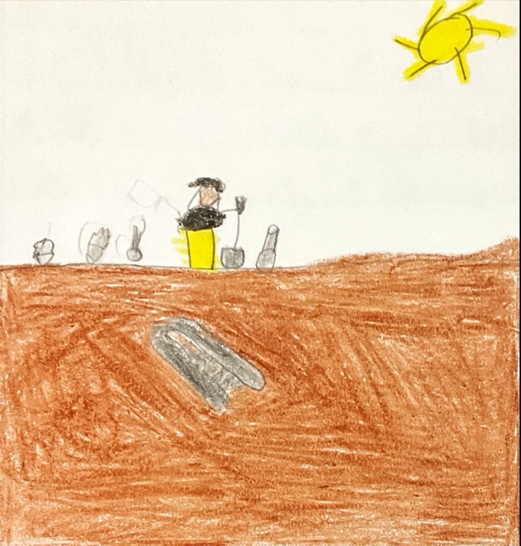

My name is Jacob Jarvis. I am out in the hot beach trying to find a pterodactyl bone. I have a pickaxe, brush, and a hammer.
I was at the hot desert. I suddenly I seen something like a fossil. I dug with i my pickaxe and brush.it was a fossil. I was surprised.
I was happy to find the fossil. I wonder how many years it was alive.
I am taking it to lab. Then when they are done, I will put it in a museum.

Written By: Jacob J.
Crew: Screech Owls
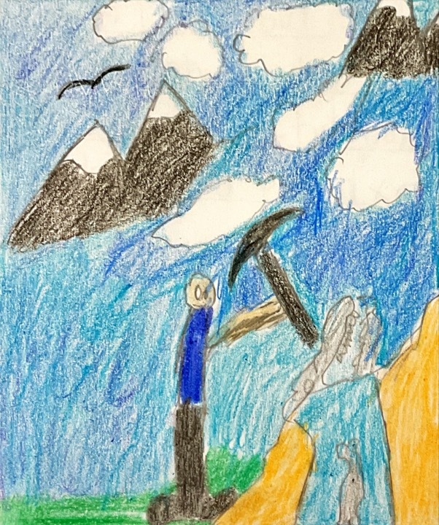

My name is Miller. I am in a rainforest. It is cold. I am looking for a t-rex fossil. My tools are a pickax, chisel, and a brush.
Then I saw something so little I could hardly see it. I whipped out my pickaxe and excavated it. WOW I thought it was so big.
Giddy with excitement I put it in my bag. At the end of the expedition, I told my friends how I thought wow!
The next day I woke up and went to the lab to examine the fossil. It was a baby t-rex skull bone. This was great to know. To figure out how baby t-rex grew up.
Written By: Miller M.
Crew: Screech Owls
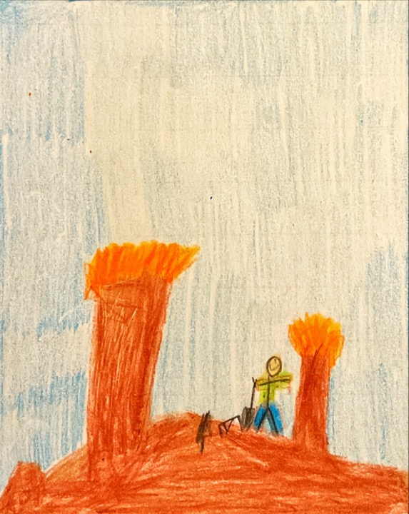

My name is Jaxson. I was looking for a fossil at the desert. I had a pickaxe and shovel.
I was digging for a fossil when I saw something. It had teeth. It was a fossil.
I was happy because I found a fossil. I wonder how old the fossil is.
After finding the fossil I am taking it to the museum.

Written By: Jaxson R.
Crew: Screech Owls
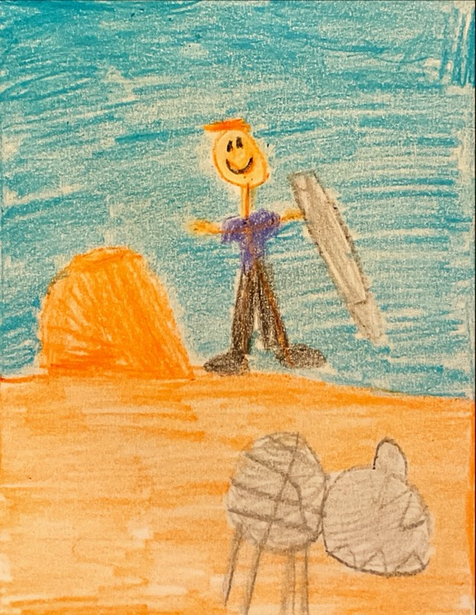

I was in the desert. I had a pickaxe and brush. I was looking for a fossil.
I brought my chisel and brush. I brush. I was searching for a fossil in the desert. Suddenly something caught my eye.it was the fossil I was looking for, I have finally found it
I was surprised that I have actually found the fossil. I have been looking for. Now I am going to take it back to the lab to study it.
It is time to go back. I found what I am for and now I will take it back to lab to study it.
Written By: Gavin R.
Crew: Screech Owls
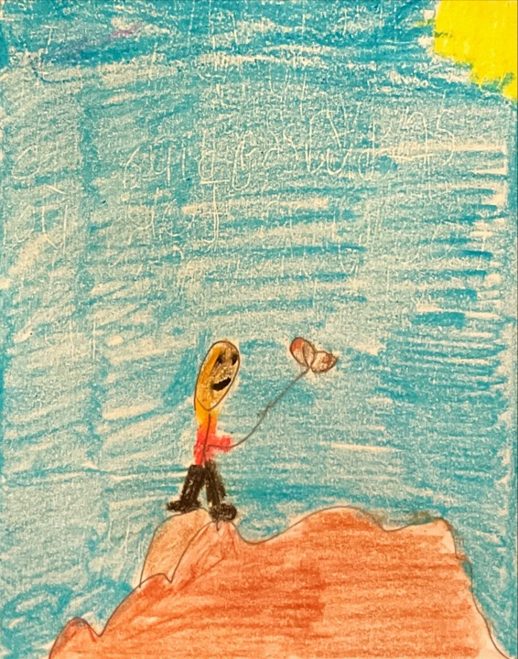

I was in the desert. I was trying to find a t-rex and I had a pickaxe, hammer, and shovel.
I was in the desert and suddenly, I found something, but it was a fossil. I was happy to find a fossil.
I was happy and excited. I thought how much work it took to find the fossil. I shared the news to my family.
After I found the fossil, I will put it in the museum, and they will study it.

Written By: Kingston R.
Crew: Screech Owls
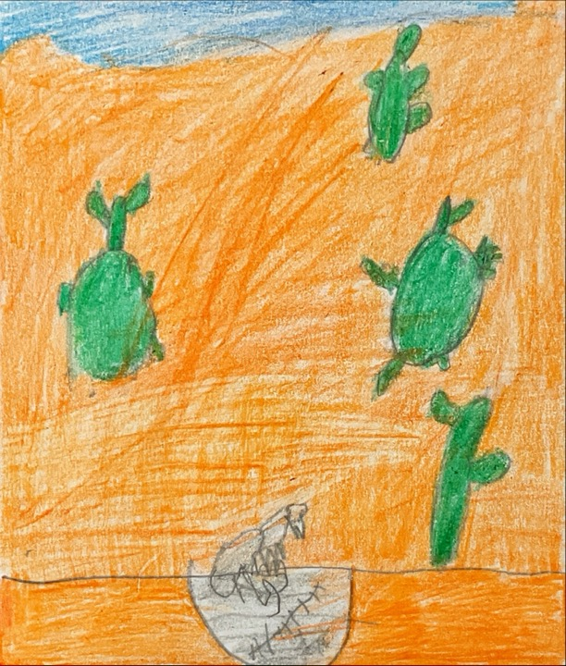

My name is Mia. I was at the beach. I had a pickaxe and shovel looking for fossils.
I was looking for a fossil when I suddenly spotted something. I got it out and it was a fossil. The fossil was round and brown.
I was happy and shocked that I found a fossil. I wonder what animal the fossil is from.
I took my fossil to the lab to learn more about it. I went to bed and woke up happy and excited I could not wait. I ran to the lab and found out that the fossil was a bone of a fish.
Written By: Mia S.
Crew: Screech Owls
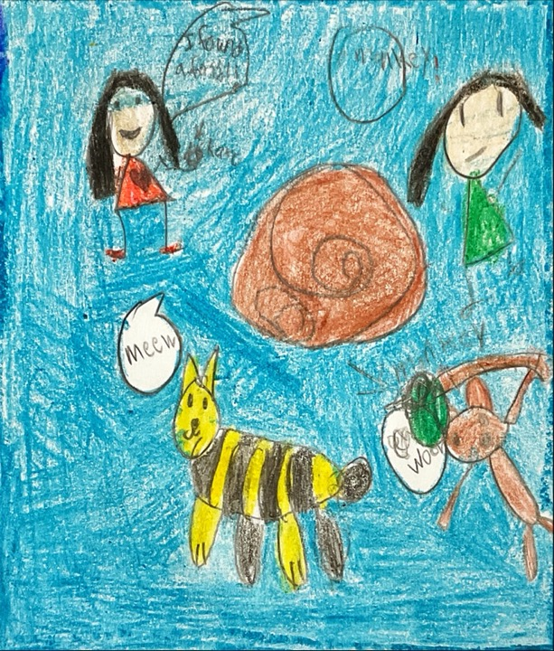

I'm at the beach finding a bone. Hammer and a chisel and a brush. Name is Arilynn.
I am digging for a fossil. Then I found one. It was big and sharp.
I was amazed because how big the fossil was. I wonder how old it is.
I took the fossil to the museum.

Written By: Arilynn T.
Crew: Screech Owls
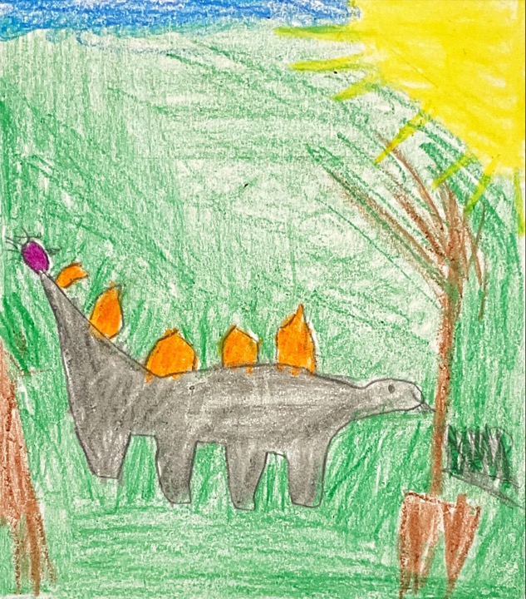

My name is Skylar. I am out in a hot desert trying to find a t-Rex bone. I have a pickaxe, chisel, brush, and a hammer.
Suddenly, I saw black line in the ground. I think found a fossil. I go to get my tools out of my bag. The fossil was big.
I was very excited to find the fossil. Then I wonder how old this fossil is.
Now, I am taking the fossil to my lab to show my friends.

Written By: Skylar W.
Crew: Screech Owls
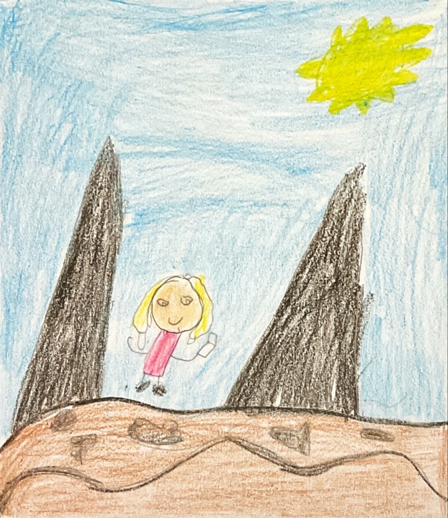

I was at the beach. I had a pickaxe with me. I saw something sticking out of the ground.
It looked like a shell stuck in a rock. I was excited!
I put it in my car and took it to the lab to study it.

Written By: Dasesean C.
Crew: River Otters
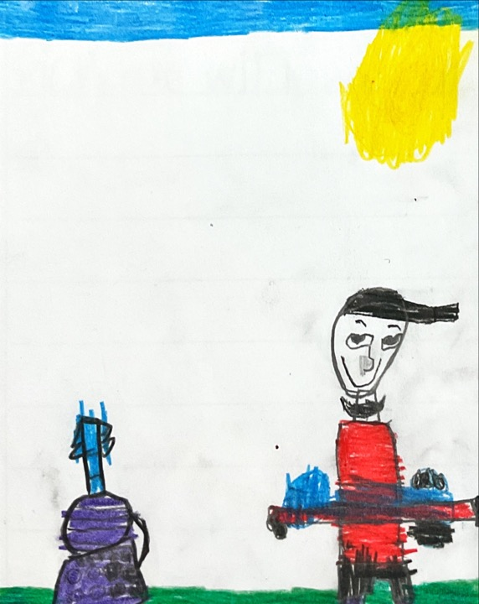
I was with my dog at the beach. We were digging for bones.
We found a skull bone. It looked like it was from a dinosaur.
I was so happy. I ran to get glue to piece it back together.

Written By: Noah C.
Crew: River Otters
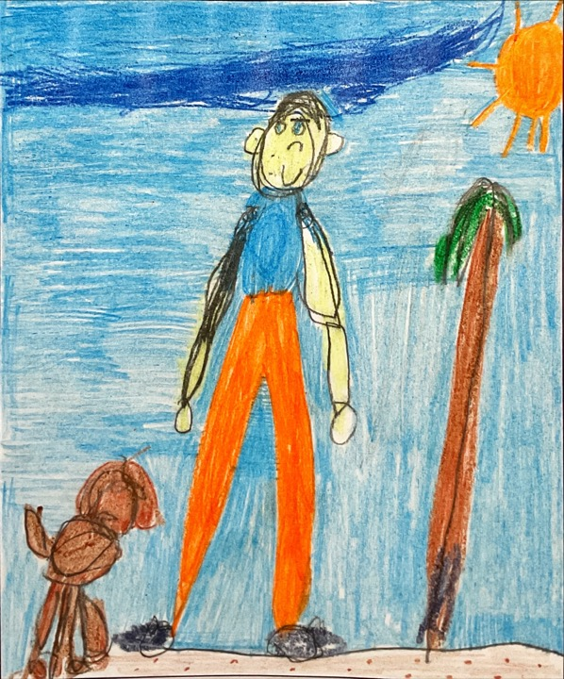

I went to the desert with my dog and a pickaxe. We tried to find a fossil.
We finally found one! I got my pickaxe. The fossil was small. It was a head.
I wanted to figure out what kind of animal it was. I took it home and studied it.

Written By: Maddyx D.M.
Crew: River Otters
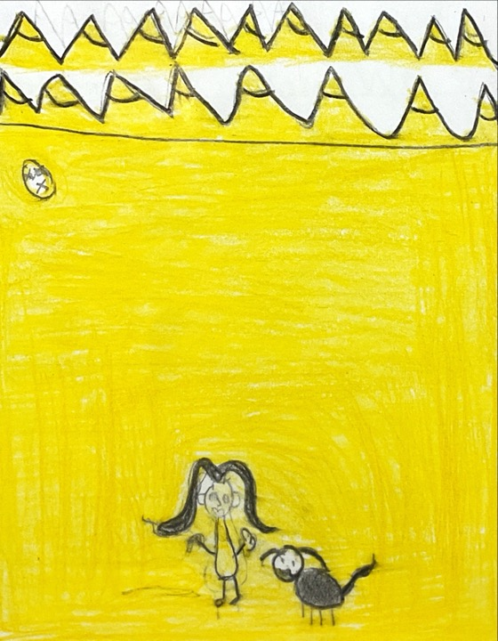

I was at the beach with my mom. I had a small shovel. I was looking for a fossil.
Then, I saw a rock and it was a fossil. It looked like an old bird wing imprint. I was so happy.
After that, I put it in my pocket. After that, I put it in my jewelry box.

Written By: Ella E.
Crew: River Otters
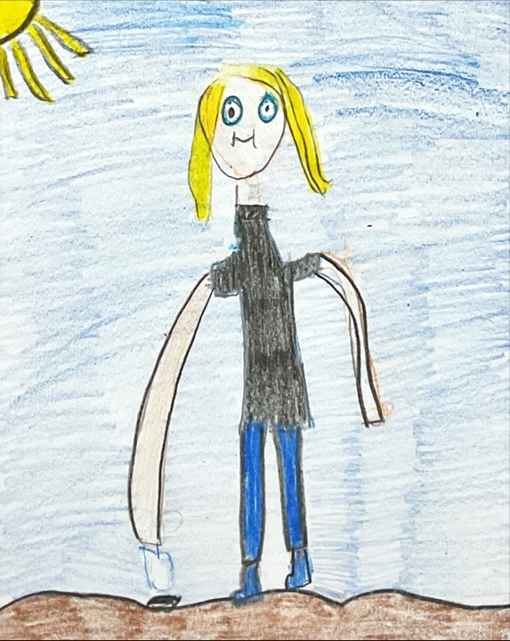

I was at the beach. I had my dog and a pickaxe with me.
I saw a bone in the sand! It was big. I wondered what it was. It looked like an arm bone!
I took a picture. I brought it home with my lab to study.

Written By: Arionna E.F.
Crew: River Otters
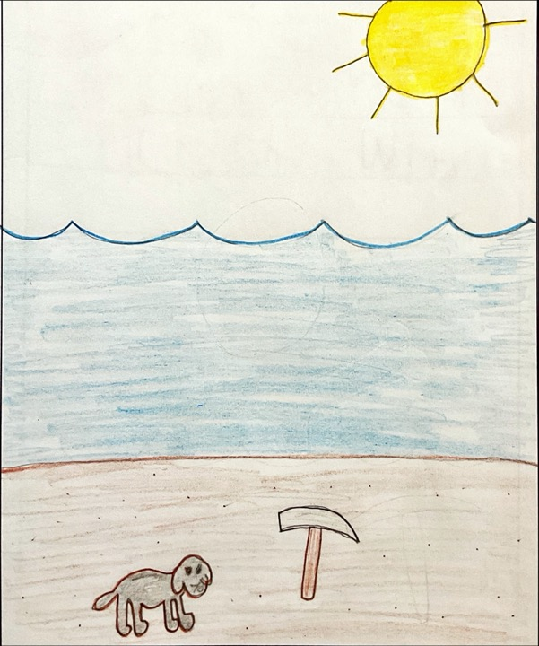

I was in the mountains. I had a dog and a shovel, and we were digging for fossils.
After a long time. It sounded like glass! Me and my dog dug it out!
I was so happy. I took it back to my lab. I studied it.

Written By: Auria F.
Crew: River Otters
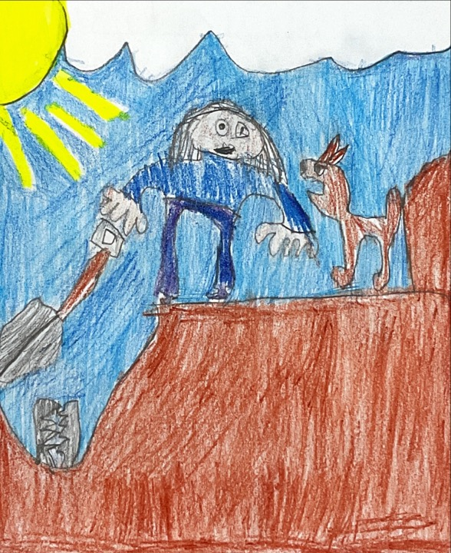

I was in a cave with my dog, Nola. I had a pickaxe and a brush.
Suddenly, Nola started to scratch at something. It was a T-Rex bone!!!!
I was so happy. I took it home to keep in my room.

Written By: Alex F.
Crew: River Otters
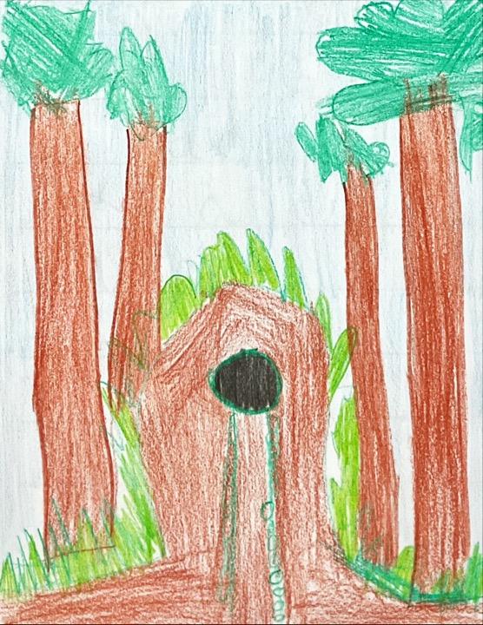

I was at the beach with my fork. I was playing in the sand. I was so happy that I found a fossil. I took it home and put it in my collection.

Written By: Anthony H.P.
Crew: River Otters
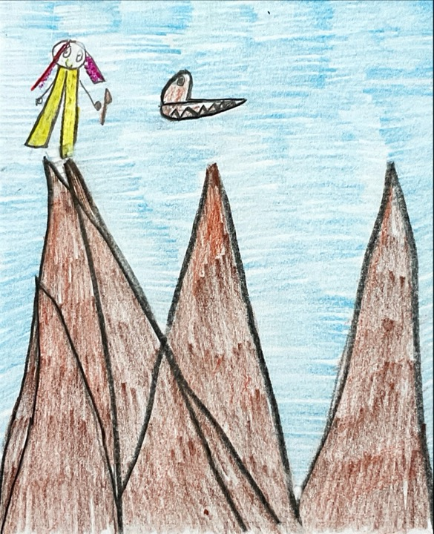

I was at a mudslide, and I was looking for a T-Rex fossils.
Suddenly, I slipped on a bone. I saw there were T-Rex fossils. They were ginormous! I
put them together and made a T-Rex. I was excited. It was amazing.
I went home to study the T-Rex. The hard work is done.

Written By: Alaina J.
Crew: River Otters
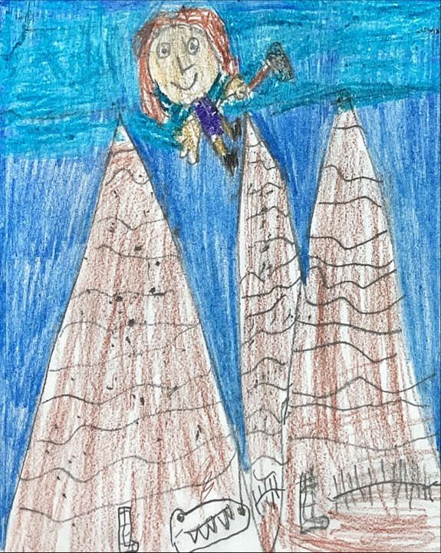

First, I was in the mountains. I had my dog, a pickaxe, and a brush.
We were digging for fossils and then I tripped over a rock. It was a fossil! I got my dog to dig the fossil out. The fossil was medium size.
I was so excited I found a fossil! I said, “I’m a paleontologist!” It was a very happy moment.
Then I got it and put the fossil into my car. Then I put it in my bedroom in my secret area.

Written By: Lilly M.
Crew: River Otters
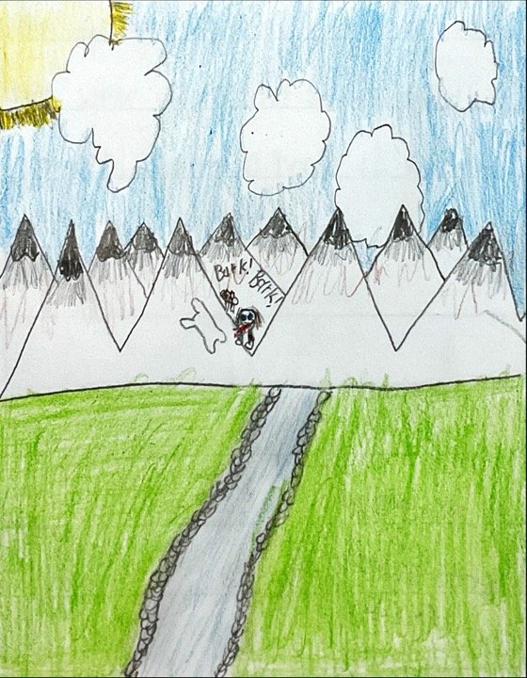

It was a rainy day. Mom was watching my brother play football. I was at the park. My nanny was watching me. I had an axe, a shovel, and a brush with me.
I saw something in the dirt. I got my shovel and brush and axe and started to dig. It was huge! It looked like a head bone.
I couldn’t believe this happened at the park. My nan was surprised. I was so happy! I took it home and I studied it because I am a paleontologist.

Written By: Marley O.
Crew: River Otters
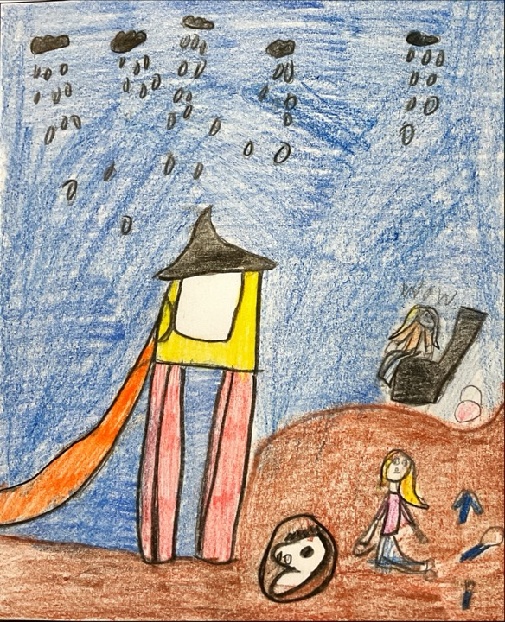

I was at the park, and I had a drill. It was a sunny day. I was hunting for fossils.
I saw a big rock. I used my drill to open it. There was a T-Rex skull inside of it.
I was so excited that I found it. I put it in a glass case so I could keep it!

Written By: Gavin R.
Crew: River Otters
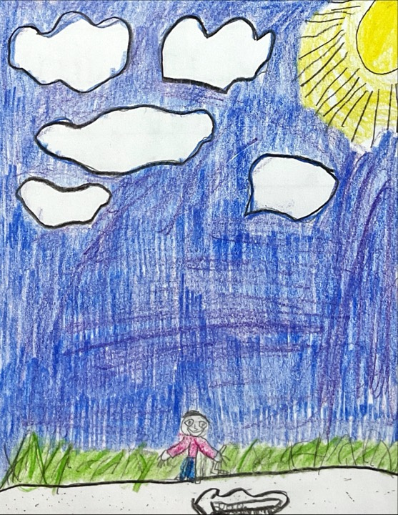

I was in a forest. I had a pickaxe, my hammer, toothbrush, and a shovel.
I was looking for fossils. I was walking and slipped. I found it! It was a large skull in a pit. I got my rope and got the skull.
I was very happy that I found it! At last, I took it to my lab to examine it. The end!

Written By: Aria S.
Crew: River Otters
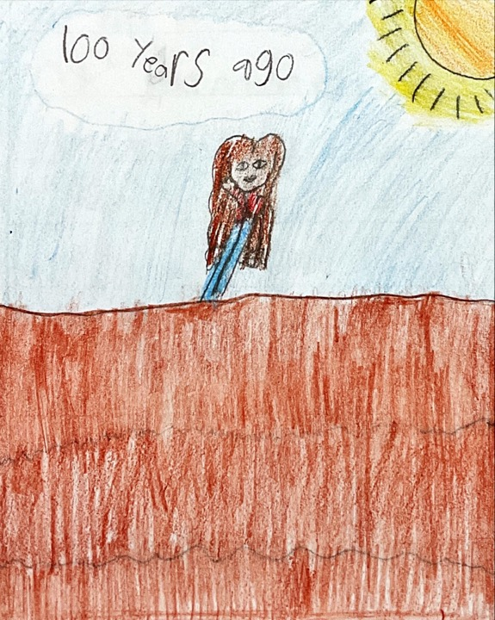

I was in the mountains. I had a dog and a hammer. We were looking for fossils!
My dog bit a fossil bone. It was small and it looked like a head. I was scared.
Then, I put it into the truck. I took it to the museum!

Written By: Soren S.
Crew: River Otters
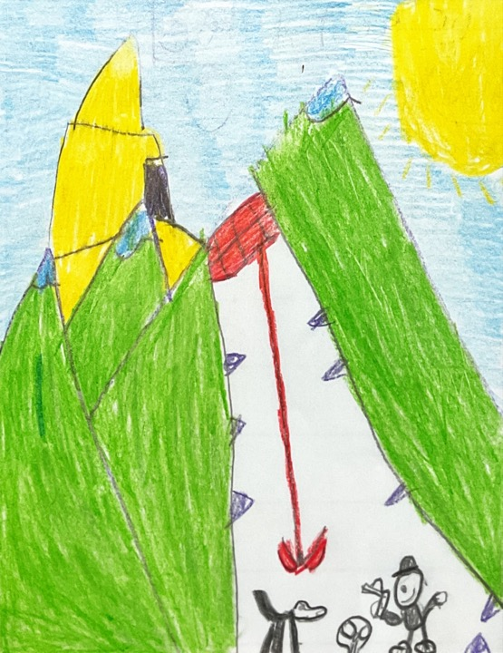

I went to the beach digging for fossils. I had my dog with me.
My dog found something in the sand. It looked like a T-Rex bone.
Yay! I finally found one! I took it to the museum.

Written By: Adelyn T.
Crew: River Otters
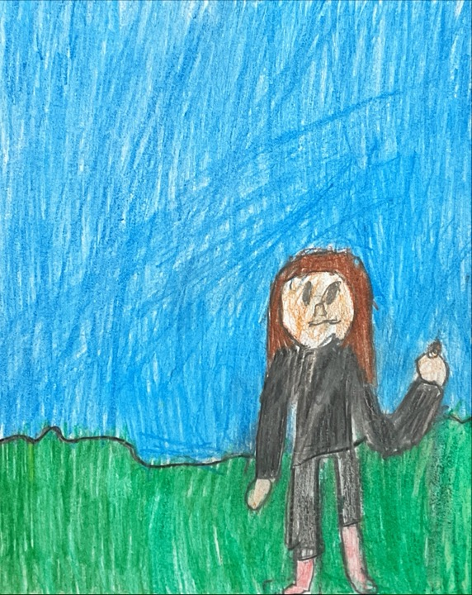

I was at the desert. I had a hammer and a pickaxe with me. I had a dog too.
This was 70 years ago. I was 8. My dog stated to dig something. A few days later, I saw that it was a T-Rex bone.
I was scared. Then, I got even more scared. I took the T-Rex bone and put it back together.

Written By: Brady W.
Crew: River Otters
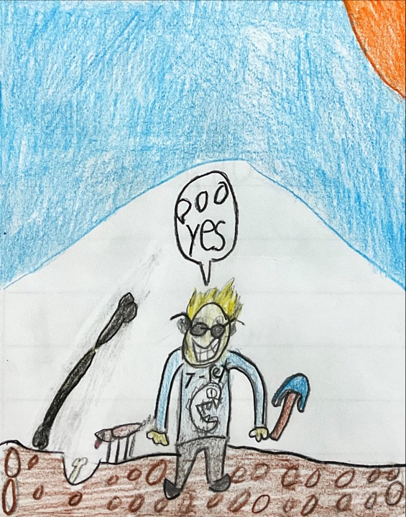

I was at the beach. I had my dog and a pickaxe with me.
I started digging until I found a fossil. I came across a tiny leg bone! I was curious to know what animal it was.
I put it in my bucket and took it home.

Written By: Hunter W.
Crew: River Otters
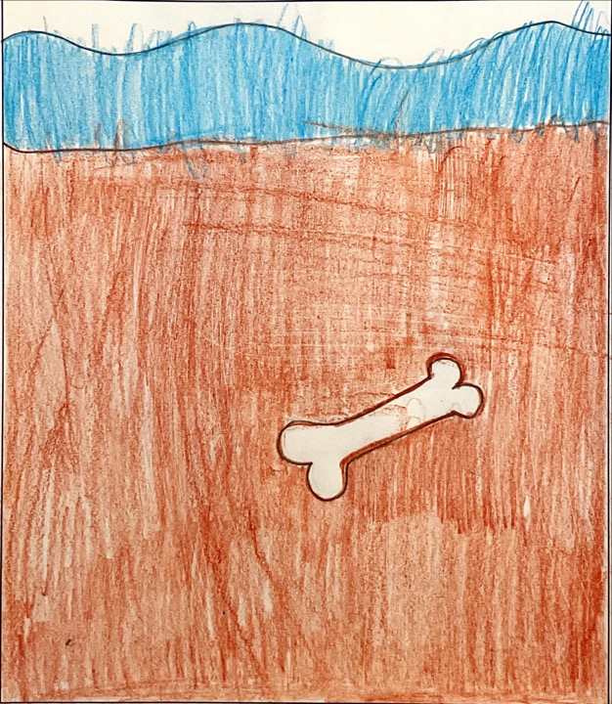

My name is Braxton. I am at the beach. I plan to find fossils. I have a pickaxe and a hammer.
I saw a little bit of the bone. So I started to dig. I used the pickaxe to dig and scoop off the dirt. I used the hammer to get the tiny bits of rock off. I found the fossil and got it out.
I am feeling happy because I found the fossil. It took me only 5 minutes. The group that was here before us dug up about 5 to 10 meters of rock.
I took the fossil back to my laboratory. It was the size of a dog. It was a baby dinosaur.
Written By: Braxton B.
Crew: Rhododendrons

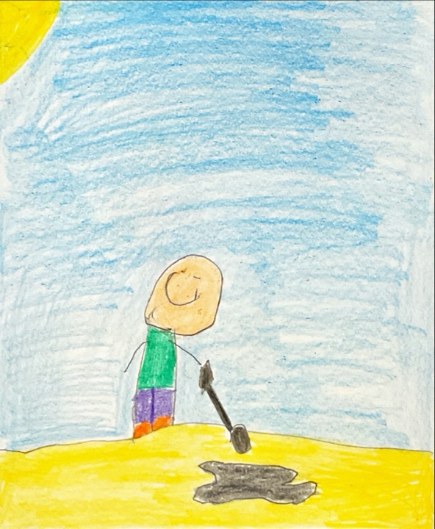
I am Nate and I am at the beach. My tools are a jackhammer and a pickaxe. I was about to leave until I tripped on something hard. I got my pickaxe out of my bag. I started digging.
When I was searching for more fossils I found another fossil and I took it back to my lab. I found out that it was from 2.5 million years.
I was happy that I found my first fossil. I took it back to my lab. I found out it was from 3.6 million years ago.
I was almost leaving until I stepped on something hard. It was another fossil. I took it back to my lab. I found out it was from 4.5 million years ago.
Written By: Nathaniel B.
Crew: Rhododendrons
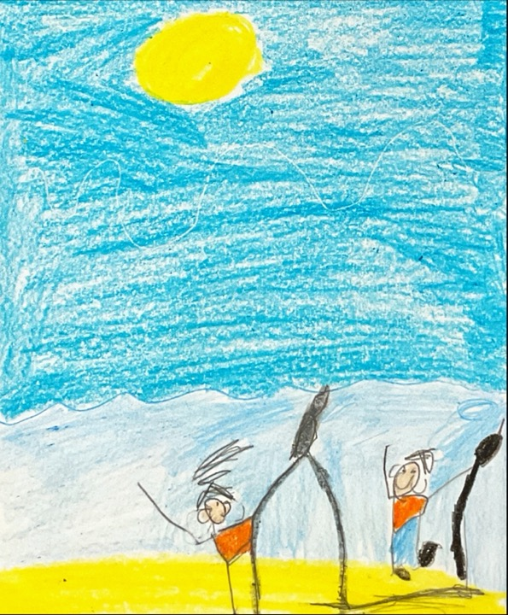

Hi my name is Cole. I am at the beach. I am looking for fossils. I have a hammer and a toothbrush.
I had to go in the water. It was sandy. I found a fossil because I saw a bone sticking out of the floor in the water. Then I dug and dug until I got the fossil.
I was happy and I was surprised. I knew it was alive millions of years ago.
I told my team about the discovery. We were so happy that we found fossils. I found out that it was alive 5 million years ago.

Written By: Cole E.
Crew: Rhododendrons
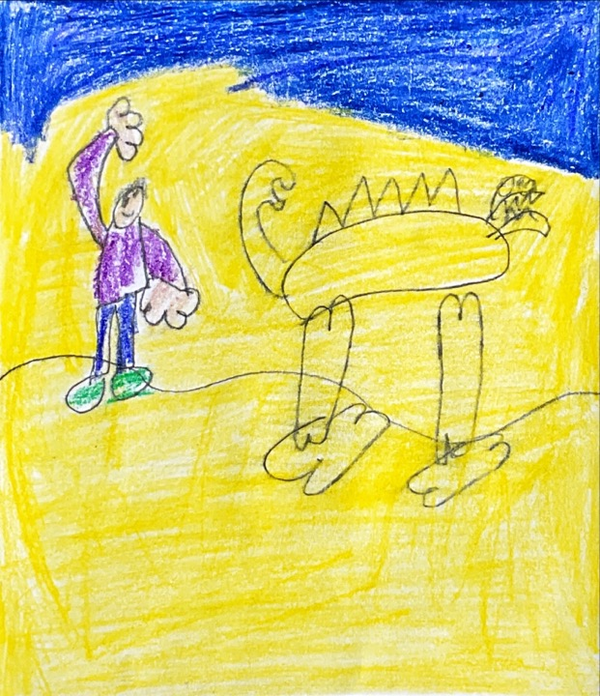

I am Kayden. I am a paleontologist. I want to find a fossil. I am in the desert. The tools I have are a pickaxe, chisel, pencil, and paper.
At first I saw something poking out of the sand. Then I grabbed my pickaxe and chisel. I slowly started to get it out. It looked like a dinosaur arm. I went to go get my friend so we could use our pickaxe and chisel to get it out.
I was happy because I found my first ever fossil!
Later I took my friend to go look for more dinosaur bones.
Written By: Kayden F.
Crew: Rhododendrons
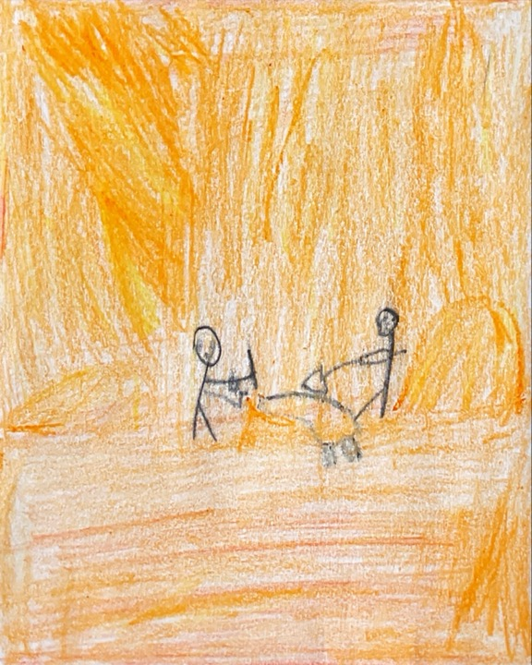

My name is Whitney. I’m at the river. I will drill the bone. My tools are drill, paper, pickaxes, chisel, and a toothbrush.
I was climbing a hill. I was digging and digging. Suddenly I hit something hard. I started to brush it. Then I started to use my chisel. I found the tip of the fossil.
I was happy because I finally found a little T-Rex fossil.
Finally, found a T-Rex fossil. I took the T-Rex fossil to the Museum of Natural History. They were so surprised to get it.
Written By: Whitney H.
Crew: Rhododendrons
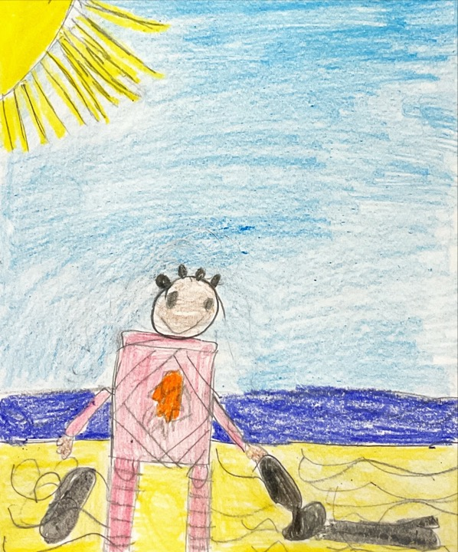

I am Lydia. I am at the beach. I am planning to find bones. I have a pickaxe and a brush.
It took so much digging. Finally I found the fossil. It took so much brushing. Suddenly I got to the bone. It was really deep.
I was so happy to find the bone. It was a delicate bone. It was my first bone I had ever found.
I took a fossil to the lab and found that It is from 3.5 billion years ago. After studying it I finally took it to the museum. I got a lot of fossils at the museum.

Written By: Lydia H.
Crew: Rhododendrons
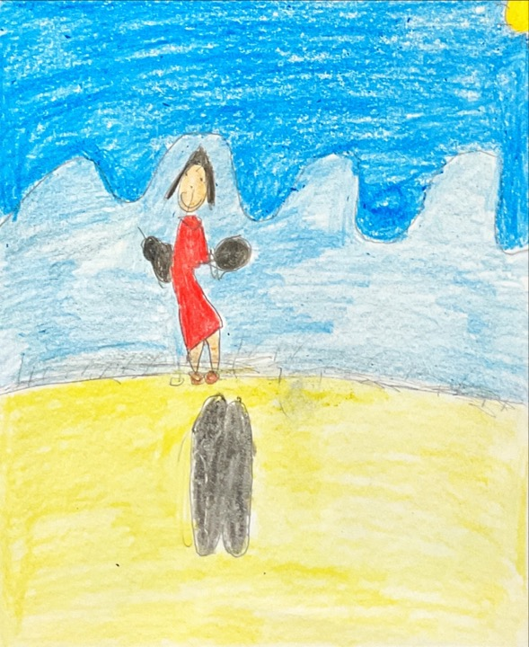

My name is Matthew. I am on the beach. I want to look for fossil.
I saw a bone sticking out of the sand. I scraped at the bone to get it out. I pulled the bone out all by myself.
I was so happy. I was happy because I got the bone out.
I took the bone by myself to my house. I put it right beside my bed in my room.

Written By: Matthew H.
Crew: Rhododendrons
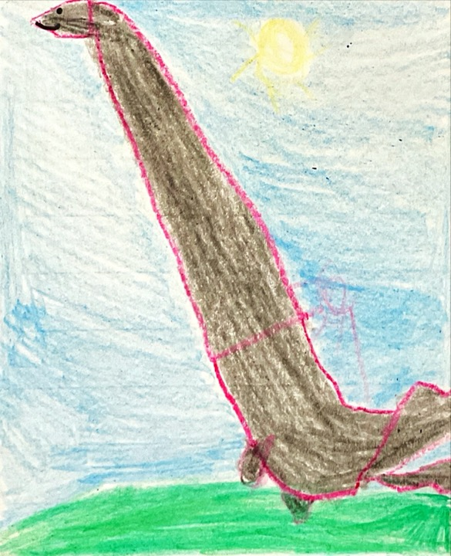
I am Jackson. I am at the desert. My tools I am using are a hammer, brush, and a pickaxe.
I was glad because I found a fossil and I was climbing, digging, and brushing. I was glad because I finally found a fossil. I took it to the lab and it was big. We studied it and examined it. I excavated it from the sand.
I was tired because I was digging and brushing. I got back up and got help to take it to the museum.
When I took it to the museum, I got help to put the T-Rex leg on the body at the museum. I was so glad I found it.
Written By: Jackson H.
Crew: Rhododendrons
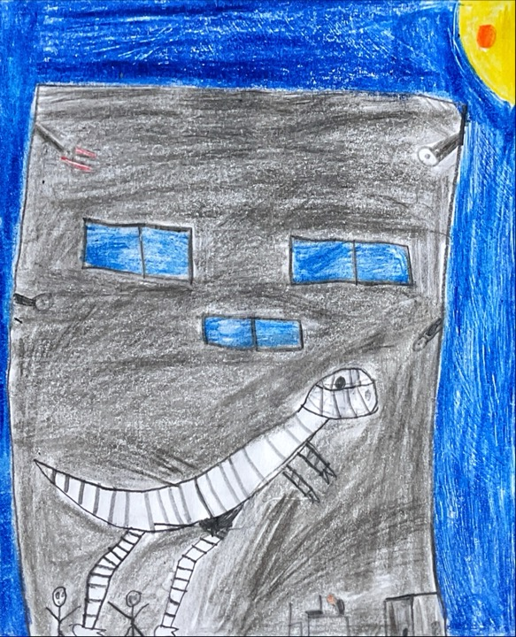

I am Emma I. I am at the desert. I am digging for fossils. My tools are a pickaxe and a hammer. I plan to find six fossils with my tools.
I came to a nice spot and started digging for my first fossil. I scraped all the rock I could. Then I felt something. It was a Saber Tooth Tiger fossil. It was amazing.
It was so exciting. Then I finally got it out.
Last I started studying the fossil. It was black and broken apart. It was 39 inches long. It was an incredible feeling.

Written By: Emma I.
Crew: Rhododendrons
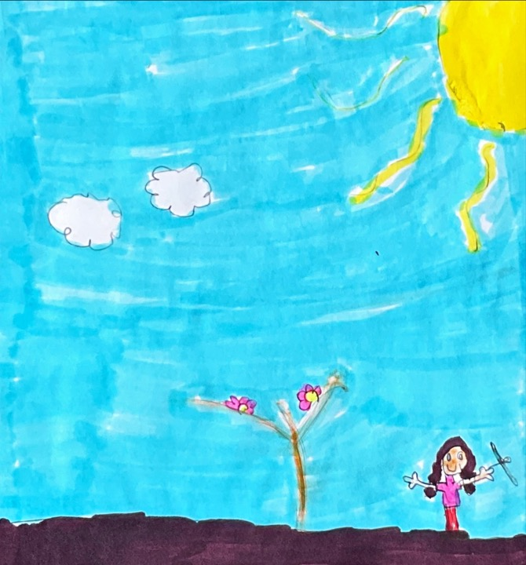

I am Emily L. I am at a mountain. My plan is to find at least 8 fossils. I have a drill, pickax, and a hammer.
I climbed to the middle of the mountain and I saw a black bone sticking out of the rock. I used my drill to get the rock off of the bone.
I felt excited to find a T-Rex skull. I felt excited because it was the first T-Rex skull I have ever found.
Finally I took it to the lab to see how old it was. It is 2 million years old. Next we tried to measure it. It was 45 inches long.

Written By: Emily L.
Crew: Rhododendrons
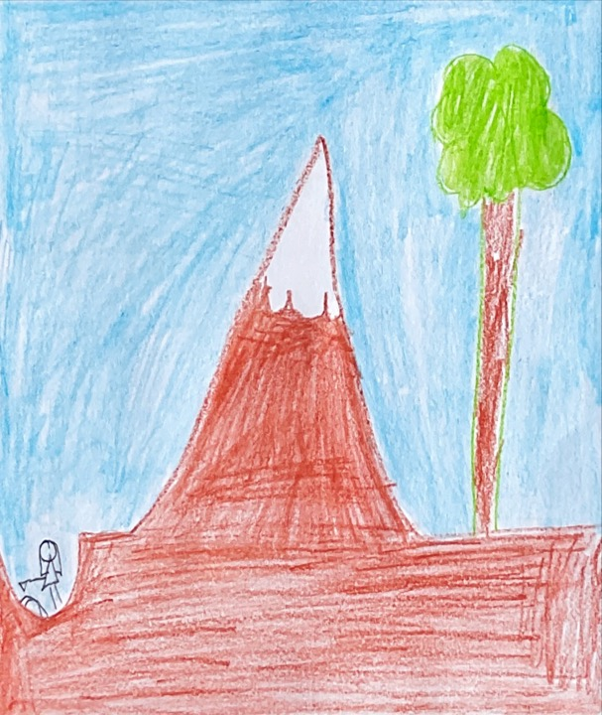

My name is Zavyer. I am at the river. My plan is to get a bone. My tools are a pickaxe, chisel, and a brush.
At first we needed to dig in the sediment. So we would get more bones I used my hammer.
I was happy because I got the biggest fossil.
Finally I went to the lab to study the T-Rex. We examined it later and we found out it was a real fossil.

Written By: Zavyer M.
Crew: Rhododendrons
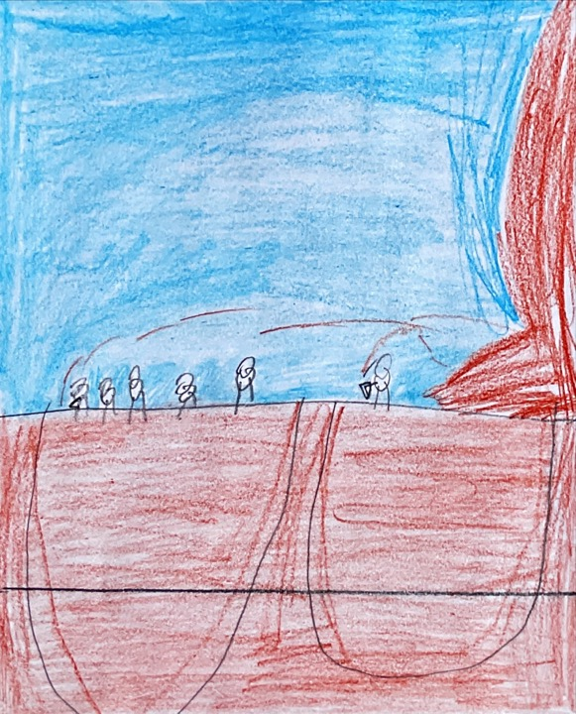

Hello my name is Madison. I am using tools. Suddenly I felt something hard in the ground. So I kept on digging and it looks like a big fossil. So I went to show my friends and my friend said “that’s awesome”.
I was using tools. I was brushing the dirt off of the fossil. I thought maybe it was a tiger or a bug. It was the smallest fossil I have ever found. I was scraping the dirt off of it.
When I was on the mountains trying to find the best fossil ever. For a minute I thought I would never find a fossil but I found one and that was the best day ever.
Finally, I decided to go get some help. So I went to my friends house.
Written By: Madison P.
Crew: Rhododendrons
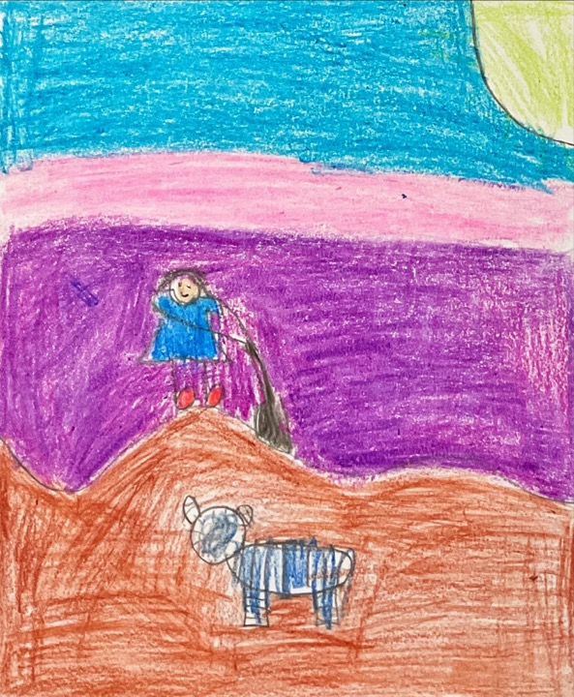

My name is Prince and I am at the mountain looking for a fossil. I have a chisel, pickaxe, brush, and a paper to write with.
I’m happy that I found my first fossil. When I was chasing my dog I suddenly found this weird thing. So I started to dig for it. It looked like a sea creature. I climbed the mountains looking for my first fossil.
When I found my first fossil I felt happy and excited. It looked like a T-Rex fossil.
I ran as fast as I can to get to the quarrymen to get this T-Rex fossil.
Written By: Prince P.
Crew: Rhododendrons
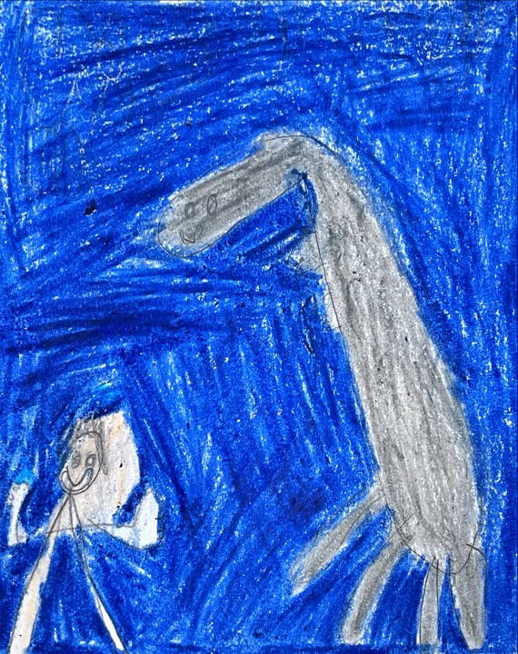

I am Erin. I am at a hill. I am digging for a fossil. I have a pickaxe, chisel, jackhammer, and a brush. I was digging for hours and weeks.
I was digging and digging for days. I couldn’t find anything. Finally for the next 6 days I finally found something. I was so tired. I thought I would get it out tomorrow.
I am digging and finally I saw a black dot. I was digging under it. I finally got it out! I was so happy to find the fossil. It was my first ever fossil.
I came back the next day trying to get the fossil out. I dug under the fossil. I finally got the fossil out! I was so happy. I took the small fossil back to my lab and asked my team if they wanted to study it. They said “yes, we will”. We studied it and found out it was a T-Rex bone.

Written By: Erin S.
Crew: Rhododendrons
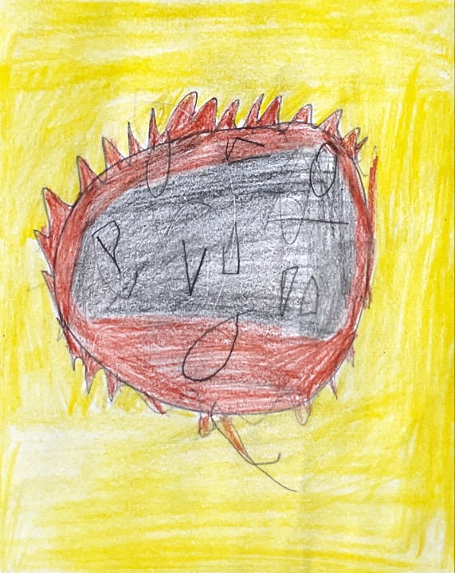

Hi, my name is Ellie. I am at the beach. I am going to dig a fossil. I have a hammer and a tiny jack hammer.
I had to go into the water because I saw a bump in the water. I used a jackhammer on the surface. It is very delicate. A few minutes later I got the fossil.
I was so happy because it was my fourth fossil. I was excited too. I knew it was alive millions of years ago.
Finally, I took the fossil to the lab. The fossil was a T-Rex fossil. Later I took the fossil to the back of the room to display.

Written By: Ellie W.
Crew: Rhododendrons
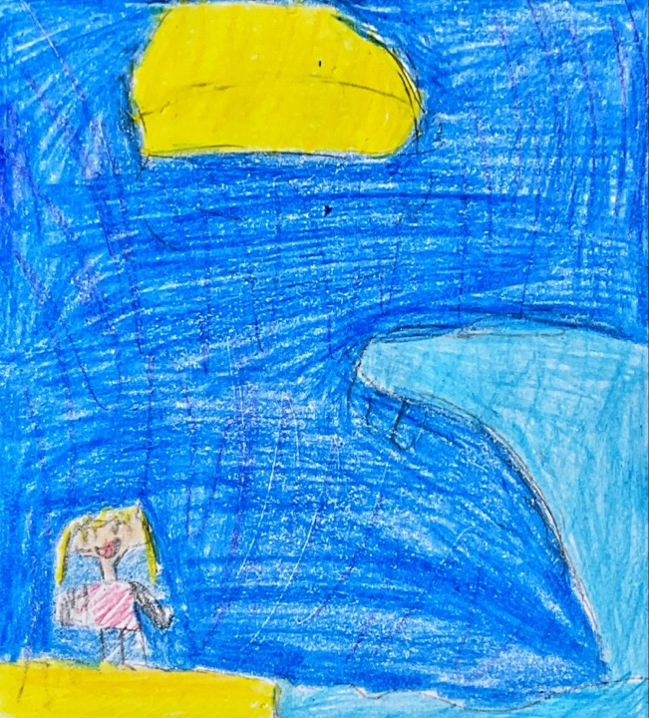

My name is John. I am at the beach playing football. I got in my backpack a shovel and a brush. I plan to find a fossil.
At first I looked in the water. I started to dig with my shovel. I saw a bone. Next I brushed off the sand. It looked like a Pterodactyl.
I was super happy because I finally found a fossil.
Then I brought it to the lab. I found it was over a hundred million years old.

Written By: John W.
Crew: Rhododendrons
